Ashcon Abae

CMSC 405 7981

1 December 2019

Project 3

The following picture is a still image of the animation I created using three.js:

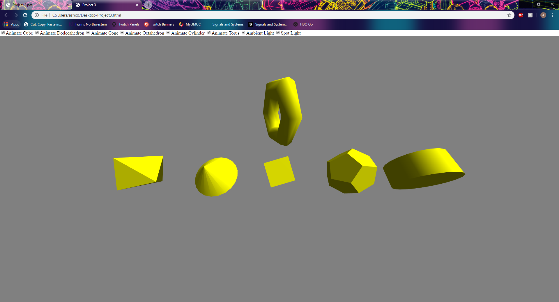  
**Figure 1**

I have created 6 shapes (cube in the middle, dodecahedron 2nd from the right, cone 2nd from the left, octahedron on the left, cylinder on the right, and torus on top). There are 2 light sources in my scene: an ambient light and a spotlight. Finally there are 8 HTML radio buttons on top of our canvas that control the animation of each of the shapes as well as the visibility of the ambient light and/or the spotlight.

To test my execution of the 3D Three.js animated scene, we will look at my solution compared to each requirement:

1. **Size: minimum 640x480**  
     
   My scene fills the browser space on my 1920x1080 monitor. Although the browser can be resized to smaller windows, the scene itself will not shrink. It simply will not be fully visible in smaller windows.
2. **Includes at least 6 different shapes**
   1. Shape 1 = Cube  
      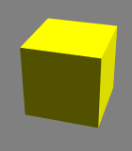
   2. Shape 2 = Dodecahedron  
      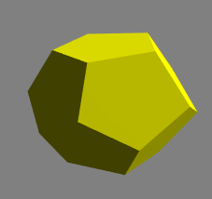
   3. Shape 3 = Cone  
      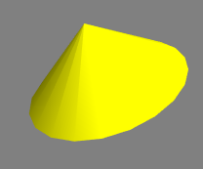
   4. Shape 4 = Octahedron  
      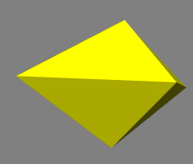
   5. Shape 5 = Cylinder  
      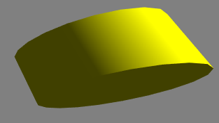
   6. Shape 6 = Torus  
      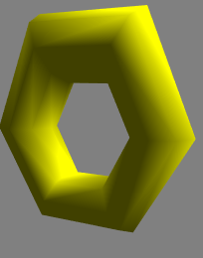
3. **Uses multiple lighting effects**  
     
   Figure 1 above shows a still image of my animation with both the ambient light and the spotlight turned on. To see the pictures of ambient and/or spotlight turned off, please look at 4.
4. **Includes radio buttons, slider bars, or other widgets to turn on or off certain components of the animation**The 8 HTML checkbox inputs I have created can be seen below:  
     
     
   From left to right, each of these checkboxes:
   1. If checked, cube is animated. If unchecked, cube pauses its animation
      1. To test this, we can simply check/uncheck this box to verify the above description is correct.
   2. If checked, dodecahedron is animated. If unchecked, dodecahedron pauses its animation
      1. To test this, we can simply check/uncheck this box to verify the above description is correct.
   3. If checked, cone is animated. If unchecked, cone pauses its animation.
      1. To test this, we can simply check/uncheck this box to verify the above description is correct.
   4. If checked, octahedron is animated. If unchecked, octahedron pauses its animation.
      1. To test this, we can simply check/uncheck this box to verify the above description is correct.
   5. If checked, cylinder is animated. If unchecked, cylinder pauses its animation.
      1. To test this, we can simply check/uncheck this box to verify the above description is correct.
   6. If checked, torus is animated. If unchecked, torus pauses its animation.
      1. To test this, we can simply check/uncheck this box to verify the above description is correct.
   7. If checked, ambient light is visible in the scene. If unchecked, ambient light is not visible in the scene.
      1. To test this, we look at the following images. Please keep in mind that Figure 1 above has checked both ambient light and spotlight (they are both visible)  
           
         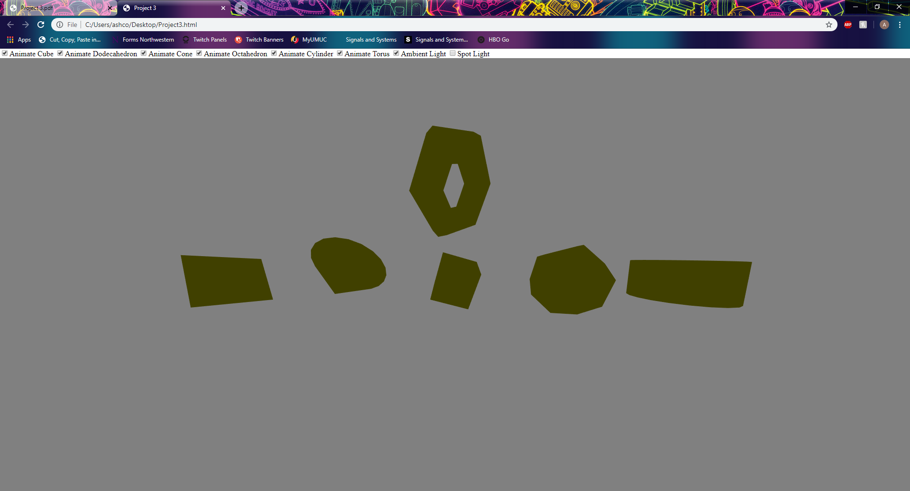  
         This image of my animation only has ambient light checked/visible (spotlight is unchecked/invisible)  
           
         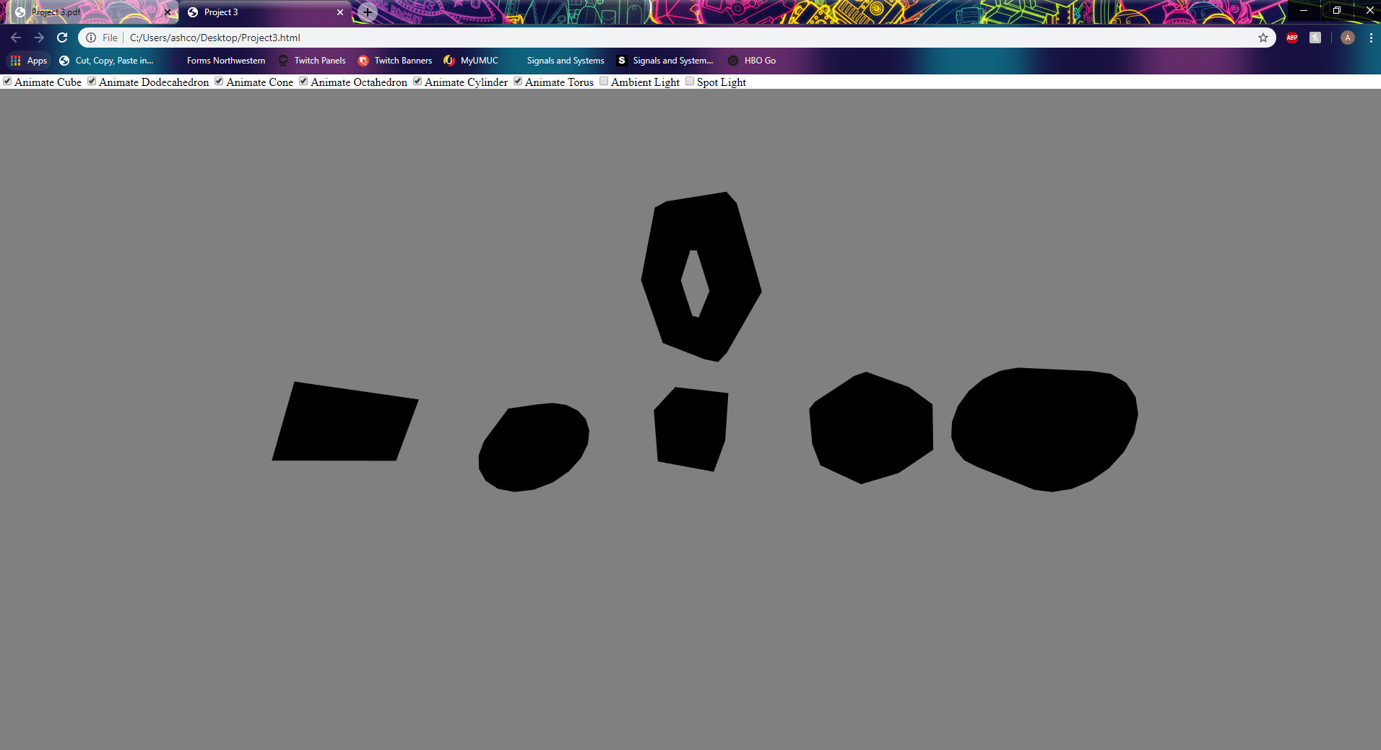  
         This image of my animation has both ambient light and spotlight unchecked (they are both invisible)
   8. If checked, spotlight is visible in the scene. If unchecked, spotlight is not visible in the scene.
      1. To test this, we look at the following images. Please keep in mind that Figure 1 above has checked both ambient light and spotlight (they are both visible)  
           
         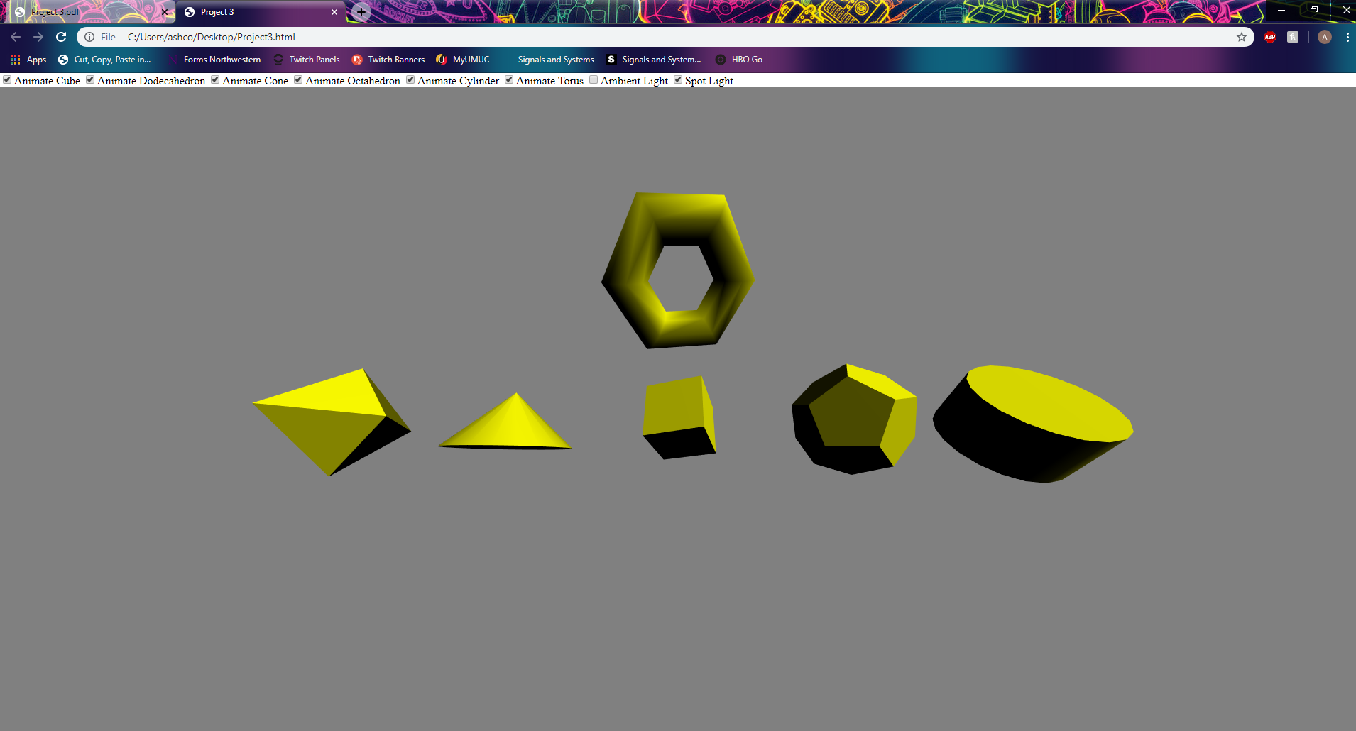  
         This image of my animation only has spotlight checked/visible (ambient light is unchecked/invisible)  
           
           
         Again, this image of my animation has both spotlight and ambient light unchecked/invisible.

Thus, my code successfully adheres to all project requirements.